**Level 0: Personal Computer Internals**

1. Create a labeled diagram of the inside of a typical personal computer.
   1. You can do it electronically or on paper.
   2. The diagram cannot be a single clip art from the web but may use individual images from the web.
   3. The labels and arrows to the various components must be drawn by you.
2. Labeling the Motherboard.
   1. Show the location of the CPU and CPU Fan. **(See photo 1)**
   2. Show the location of the Memory Slots and RAM Memory. **(See photo 1)**
   3. Show the location of the on-board video, sound, Ethernet/Wireless and USB devices. **(See photo 1)**
   4. Show the location of the expansion slots and Video and Sound boards. **(See photo 1)**
3. Labeling the Chassis Components.
   1. Show the location of Power Supply. **(See photo 2)**
   2. Show the location of the External Hard Drives and connections to the Motherboard. **(See photo 1,2)**
   3. Show the location of the Removable Media Drives and connections to the Motherboard. **(See photo 2)**
   4. Show and label the external connector plate (i.e. where the monitor, keyboard, etc. are connected.) **(Photo 1)**

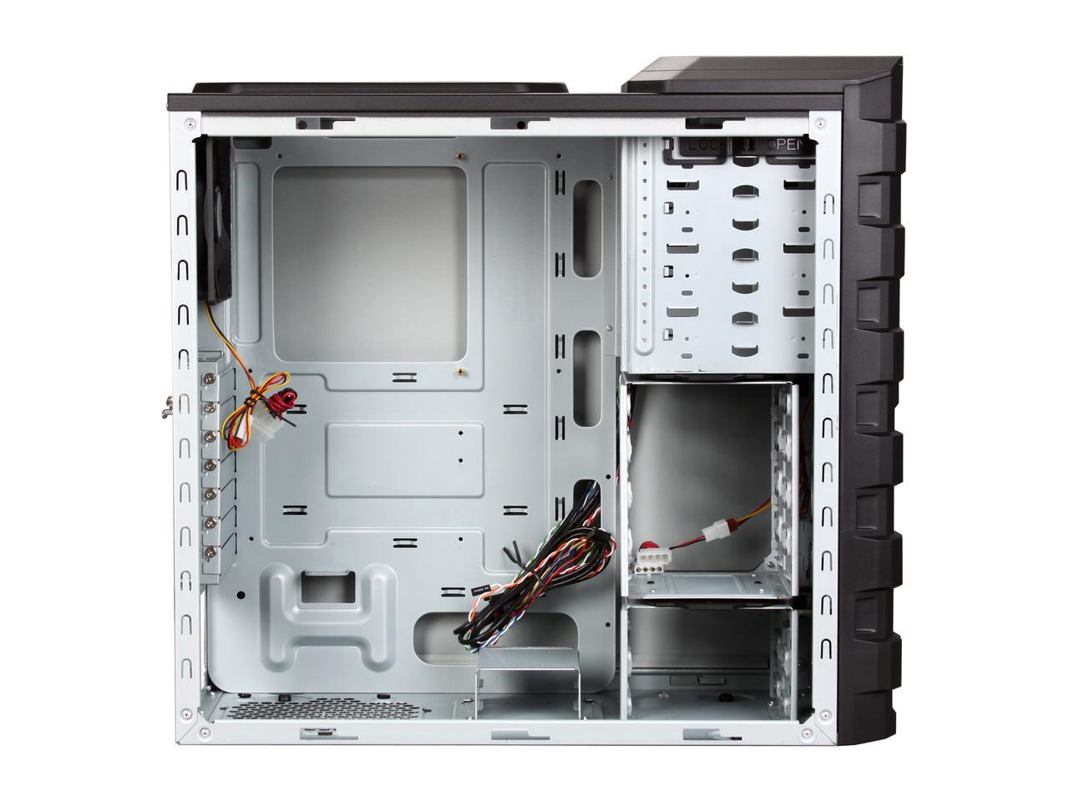

C

B

A

Level 0: Photo 2

Level 0: Photo 1

D

B

A

C

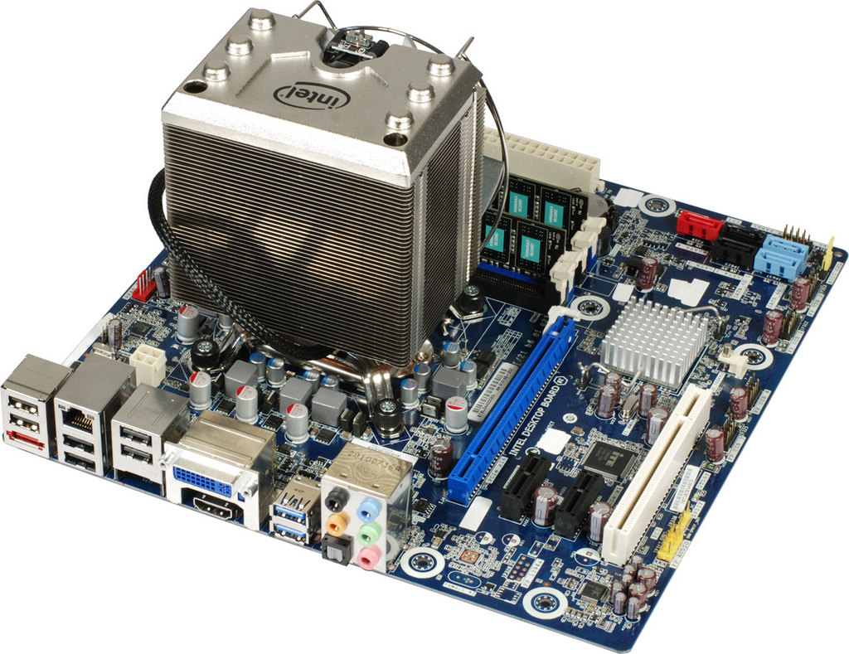

3.D

3.B

**Level 1: History of Computers**

1. *Research the history of “Mainframe Computers”. Make notes on the following:*
   1. ***The first computers (e,g, UNIVAC) and how they were made.***

* Many of the first Main frame computers were produced within the years 1950’s all the way through the 1970’s.
* These computer were huge in size, taller than many humans
* Main frame computers are usually used by large organizations to process large amounts of information
* The first main frame computer was manufactured by IBM which solved addition and multiplication problems in less than six seconds.
* The UNIVAC was the first commercially available computer for people to use
* the Univac handled both numbers and alphabetic characters equally well. the univac i was unique in that it separated the complex problems of input and output from the actual computation facility
* The machine was 25 feet by 50 feet in length, contained 5,600 tubes, 18,000 crystal diodes, and 300 relays. It utilized serial circuitry, 2.25 MHz bit rate, and had an internal storage capacity 1,000 words or 12,000 characters.
* The ENIAC, the first large-scale computer to run at electronic speed without being slowed by any mechanical parts.
  1. ***Computers in the 1960s and 1970s (e.g. IBM)***

**1960’s**

* In the 1960’s the Mainframe computer was just being improved like making parts smaller and more reliable transistors
* and was getting more public than compared to the 1950’s
* Computers were now available to the public
* Some games were also programmed
* The computers were getting more advanced and could do more than the computers in the 50’s some things include
* Some new software/program languages were being developed like:
  + COBOL
  + CTSS
  + And many more
* The US Navy Tactical Data System uses computers to integrate and display shipboard radar, sonar and communications data

**1970’s**

* The introduction of the ATM’S
* Newer programming languages are introduced
  + Pascal
  + C
* Computers began to downsize
* Arcade games are developed(Computer space one of the earliest)
* Hand held scientific calculators
* The laser printer is invented at Xerox
* We got to see more network like the Email
* Pong
* More productivity type computer like drawing systems like super paint
* TV typewriters
* The IBM 3850 mass storage system is introduced
* Xerox PARC Alto introduced, this computer had a massive impact on the computer industry. It was based on a graphical user interface using windows, icons, and a mouse, and worked together with other Altos over a local area network. It could also share files and print out documents on an advanced Xerox laser printer.
* The Apple 1
* Apple II introduced, Sold complete with a main logic board, switching power supply, keyboard, case, manual, game paddles, and cassette tape containing the game Breakout.
* The 70’s were mainly big about the upcoming personal computer
  1. ***Modern mainframe computers used by banks, government, and other large companies***
* Banks use main frame computer so we can interact with our bank account.
* Main frame computers are used by large corporations (e.g. Apple), banks, and governments
* Until the mid-1990s, mainframe computers provided the only acceptable means of handling the data processing requirements of a large business.
* Because of these design strengths, the mainframe is often used by IT organizations to host the most important, mission-critical applications.
* Many of today's busiest Web sites store their production databases on a mainframe host.
* Corporations use mainframes for applications that depend on scalability and reliability. For example, a banking institution could use a mainframe to host the database of its customer accounts, for which transactions can be submitted from any of thousands of ATM locations worldwide.

1. *Research the history of “Super Computers”. Make notes on the following:*
   1. The first super computers (e,g, CRAY) and how they were made.

* the Cray CDC 6600 supercomputer was introduced, as one of the world's first supercomputers - and was considered to be the most powerful computer in England
* Known as the first successful supercomputer
* it outperformed its fastest predecessor, the IBM 7030 Stretch, by a factor of three
* The first CDC 6600's were delivered in 1965 to the Livermore and Los Alamos National Labs
  1. Massively Parallel and Network Computers (e.g. Big Blue)
* A computer that is connected with one or more other computers for the purpose of communication and file sharing
  1. Modern quantum computers and how they work

• a computer that makes use of the quantum states of subatomic particles to store information.

1. *Research the history of “Personal Computers”. Make notes on the following:*
   1. When was the first IBM PC introduced and what features did it have?

* The IBM PC was introduced August 12, 1981, which were 36 years ago It is IBM model number 5150.
* Some of its features include:
  + Floppy disk or cassette system. One or two internal floppy drives were optional.
  + First IBM PC to come with an internal hard drive as standard.
  + 5160 with XT/370 Option Kit and 3277 Emulation Adapter
  + With 3270 terminal emulation, 20 function key keyboard
  1. What were some PCs before the IBM PC?
* MITS Altair 8800,
* IMSAI 8080,
* Apple 1
* Apple 2
  1. When was the first Apple introduced and how was it different from the PC?
* The first apple Pc Came out in April 11, 1976 which was 41 years ago
* The apple 1 was Quite different compared to the IBM PC, The main reason was because apple 1 was apples first PC and IBM were in the computer business for a long time, some differences include:
  + Apple 1 was homemade and IBM was assembled in a factory
  + Apple 1 had a wooden case and IBM PC had a plastic case
  + The IBM came with a separated keyboard and monitor while apple 1 was 1 piece
  + The IBM PC was worth $1,565 while the apple one was worth $666.66
  1. How have modern PCs change since the earliest PCs?
* New PC’s are now cheaper compared to old ones
* New PC’s Better Graphics
* More applications and features
* Faster speed(booting time, starting a progam,….)
* Less noise
* More compact
* ….

**Level 2: History of Computer Components**

1. Research the history of the “CPU Chip”. Make notes on the following:
   1. When was the first CPU chip released (e,g, 8086) and who made it and what did it contain.

* Intel 4004 became the first general-purpose programmable processor on the market
* Federico Faggin was the leader for the 4004 project
* It was the first commercially available microprocessor by Intel
* It contained:
  + Maximum clock speed of 740 kHz.
  + Up to 92600 instructions per second.
  + Separate program and data storage.
  + 12-bit addresses.
  + 8-bit instructions.
  + 4-bit words.
  1. What is an “Integrated Circuit” and how were computers made before ICs?
* An electronic circuit formed on a small piece of semiconducting material, performing the same function as a larger circuit made from discrete components.
* Early computers depended on vacuum tubes to amplify electrical signals throughout the machine. Vacuum tubes were large, made of glass, and required regular maintenance: not exactly something that could be put into a consumer device.
  1. How have CPU chips evolved since the 8086?
* early microprocessors were 8bit, the industry had moved on to 16bit and 32bit processing by the mid-1980s, which helped pcs to run multiple applications at once.
* Performance increased as the number of transistors on the microprocessor doubled every other year
* Demand for mobile phones was also growing at this time and, as it grew, so too did the need for energy efficient processing.

1. Research the history of “Computer Memory”. Make notes on the following:
   1. How is RAM memory used in PCs different from “Core Memory” used on early computers.

On the PC the more Ram you have the better, this is because you need more ram soyou can multi-task more efficiently.

* 1. What is “Moors Law” and how has RAM memory followed this law?
* Was an observation made by Intel co-founder Gordon Moore in 1965.
* Moore noticed that the number of transistors per square inch on integrated circuits had doubled every year since their invention.
* The law predicts that this trend will continue in the future
* Just like the transistors, RAM has also followed this law by the RAM decreasing through the years
  1. How is RAM memory different from external memory (e.g. hard disks)?

Because ram uses flash memory like an ssd. Is is superfast in comparison to a 5400 rpm harddisc.

* 1. How has RAM memory evolved over time?

The biggest development Ram has had over time is the smaller size and much more space and more efficiency

1. Research the history of “Video Cards”. Make notes on the following:
   1. What is VGA, when was it introduced and what features did it have?

* VGA means video graphics array
* is the display hardware first introduced with the IBM PS/2 line of computers in 1987.
* VGA cables have 15-pin connectors: 5 pins at the top, 5 in the middle, and the other 5 at the very bottom.
* VGA provides 640 x 480 resolution color display screens with a refresh rate of 60 Hz and 16 colors displayed at a time. If the resolution is lowered to 320 x 200, 256 colors are shown.
  1. What came before VGA graphics?

Enhanced Graphics Adapter.

* 1. When were 3D graphics cards introduced and what were the first 3D cards like?

Fujitsu's MB14241 video shifter was the first 3D graphics.

* 1. How have graphics cards evolved over time?

Computer hardware is constantly evolving, with components becoming smaller and more powerful.

Graphics card performance has changed a lot over the past 30 years, from only displaying rows of characters to rendering photorealistic scenes in real-time.

The appearance and designs of graphics cards have also experienced radical changes, with manufacturers upgrading PCB components and experimenting with cooling systems.

Many companies attempted to break into the GPU market, but it has historically been dominated by Nvidia and AMD (ATI).

**Level 3: History of Operating Systems**

1. What is a “Operating System”?
   1. How is it different from a software program

* System software is a type of computer program that is designed to run a computer's hardware and application programs.
* Operating System is the software that supports a computer's basic functions, such as scheduling tasks, running applications, and controlling peripherals.
  1. What is a “Driver”?

A group of files that enable one or more hardware devices to communicate with the computer's operating system. Without drivers, the computer would not be able to send and receive data correctly to hardware devices, such as a printer.

* 1. What is a “Service”?

A network service is an application running at the network application layer and above, that provides data storage, manipulation, presentation, communication or other capability.

1. Research the history of the “Windows” operating system. Make notes on the following:
   1. What is DOS and how is it related to Windows?

* Dos is an operating system that runs from a hard disk drive.
* The only reason DOS is related to Windows is because both were an operating system
* Also the first windows system had an existing MS.DOS installation
* However, DOS was Not the best as you would have to enter a command for every little thing.
  1. What was the first version of Windows, when was it released and what did it contain?
* Windows 1.0 was released on November 20, 1985, as the first version of the Microsoft Windows line
* Some features include:
  + It runs as a graphical
  + 16-bit multi-tasking shell on top of an existing MS-DOS installation.
  + It provides an environment which can run graphical programs designed for Windows
  1. Compare the history of the Apple OS with Windows?
* Apple OS has a great history of no viruses, compared to the windows operating system which usually does get a virus
* The operating system has been neck to neck as of the appearance and features throughout the years
* There was also some controversy with bill gates stealing the idea of the apple OS
  1. How has Windows evolved over time?
* Windows has gone through some big changes, at first the operating system was not the best, with very basic tools to use
* As the years went on Microsoft improved the way the system looked, and had more to offer to the user.
* Now it is one of the best operating systems in the world

1. Research the history of “UNIX”. Make notes on the following:
   1. What is UNIX and what is the history of UNIX.

* Unix is a multiuser operating system
* is a set of programs that act as a link between the computer and the user?
* this system is not user friendly
  1. What is LINUX and how is it related to UNIX?

*Linux:*

* Just like Windows XP, Windows 7, Windows 8, and Mac OS X, Linux is an operating system.
* An operating system is software that manages all of the hardware resources associated with your desktop or laptop
* the operating system manages the communication between your software and your hardware. Without the operating system (often referred to as the “OS”), the software wouldn’t function.

*Link between Linux and Unix:*

* the original Linux kernel was modeled after a version of UNIX, and even its creator at times has related it to UNIX.
  1. How is UNIX related to the Apple OS?
* Apple OS is related to Unix because Apple OS actually branched of and improved the original Unix software.
* Many other companies did the same like Apple.